Problem Statement: Multiple Cases of monkeypox has been reported this year in areas where it had not been endemic and this has led to an increase worldwide. This report seeks to lay bare the analytical statistics related to the disease for public consumption

AIMS grid:

Purpose: To unlock insight to occurrence and other statistics relating to monkeypox

Stake holders: Author, General public.

End Result: Automated dashboard that provide quick insight

Success criteria: Dashboard able to give numbers with respect to monkeypox statistics.

* This is an end-to-end Data analysis project that produced a report that allows stake holders to consume information relating to monkeypox occurrence
* The data set was extracted from <https://global.health> and downloaded from <https://www.kaggle.com/datasets/andrewmvd/global-monkeypox-cases> , completed initial exploration to understand data using Excel and MS SQL server
* Imported 39K records, performed data transformation in Power Query using GUI and M language.
* Cleaning and Transformation includes:
* Filtering irrelevant columns
* Filtering rows where date of confirmation is ‘null’ and based on that created a case count column
* Created dimension date table to assist with slicing
* Other column calculations and creation of measures and parameters were completed with DAX language in main Power BI platform
* Built dashboard in power BI from scratch that provide key insight
* Key Conclusion includes that:
* Number of hospitalised (44%) is less compared to not-hospitalised persons which gives an insight about the level of sickness caused by the virus
* More males are affected compared to female

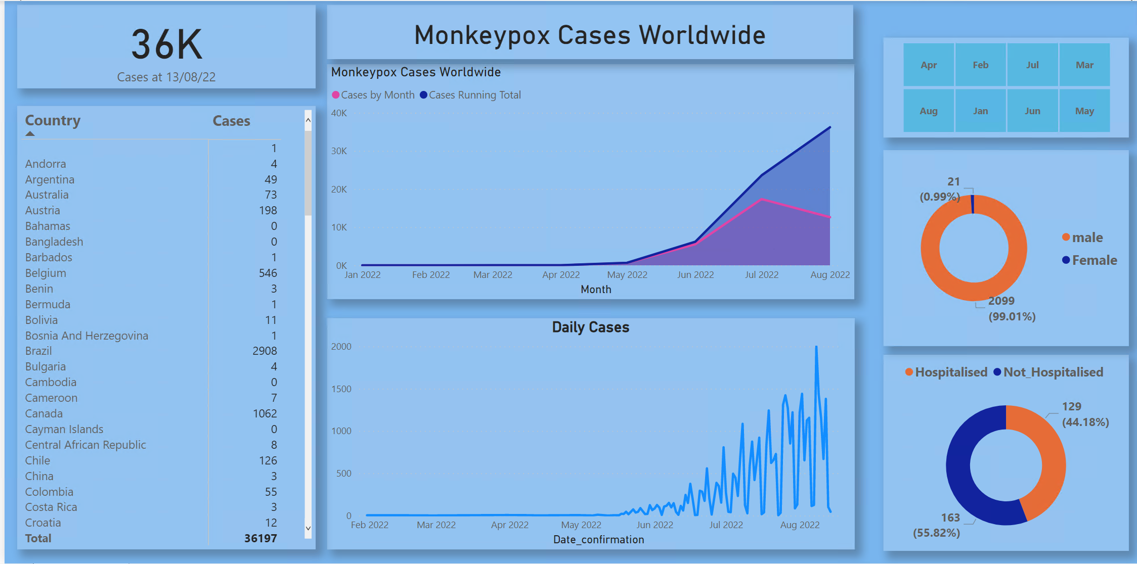

Insights:

1. Dynamic Title that displays the statistics related to selected country filter, below:

Canada has 531 male cases reported without any reported for female in this data

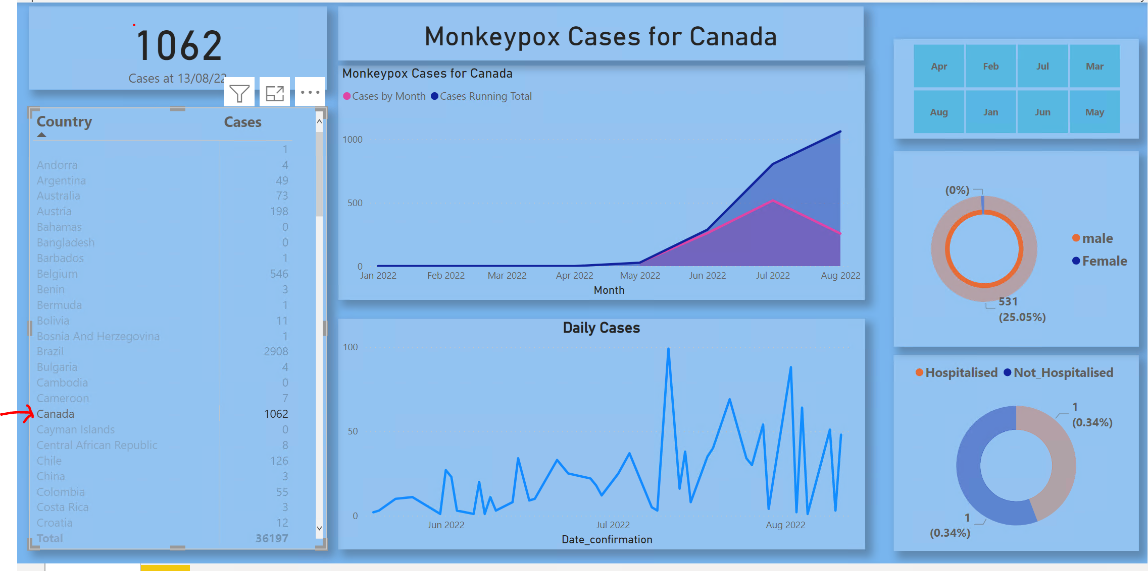

1. Numbers for both monthly, daily, as well has running total can be consumed for worldwide and for any location.

Conclusion

1. It can be seen that about 99% of cases are male with about 40% reported hospitalisation,

However more data is needed for better and convincing analysis